**Navigation Guide for Administrators**

Cost Tool users whose accounts are granted ‘superuser’ status see several additional menu items and pages when they log into the system.

In the main window of the Cost Tool there is an additional menu item ‘AUDIT’. The Audit page has a list links to pages that provide an easy way to review and export data from the system. The AUDIT menu item is displayed for both ‘superuser’ and ‘staff’ accounts.

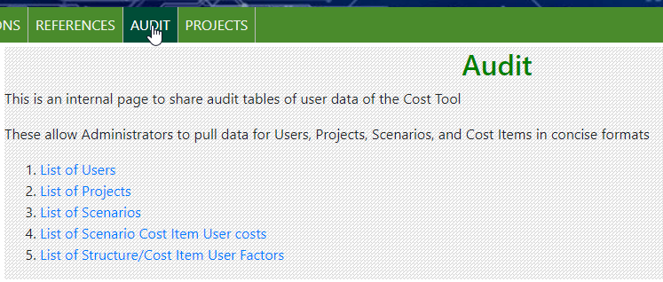

Each of the audit pages have similar features.

1. The tables can be sorted by clicking on the column headers.
2. The tables can be filtered using the Search box.
3. There are at least 3 download formats ‘Copy’ (to clipboard), ‘CSV’ (comma-separated-values), and ‘Excel’. The Audit Scenarios page has an additional format ‘Detailed Excel’ The detailed excel button has additional column containing most of the data for each Scenario.

When a superuser logs into the GSI Cost Tool, the menu in the upper right corner of the screen has 1 additional option not available to non-superuser accounts. Use the first option ‘Admin Page’ to open the 'GSI Cost Tool Admin Page.'

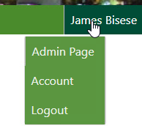

On the GSI Cost Tool Admin Page the superuser can add, edit, and delete data. The superuser can select any option by selecting the name of the option, or the 'Change' menu button.

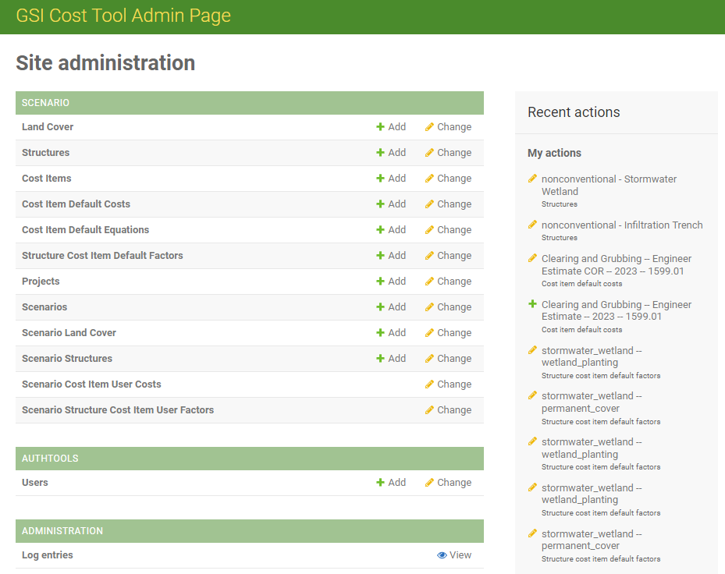

At the bottom of the page is a set of links to Microsoft Word documents that make up the Site administration Documentation. Each document has details on how to make edits and updates. Two documents describe how to administer user accounts, and five describe who to manage the look-up tables in the system.

